The Big Mountain Resort, believing their admission ticket pricing was undervalued in the current market, asked us to look into pricing models and regressions between their resort and others located in the United States. The data used, contained ticket pricing and resort feature numbers from 330 unique locations.

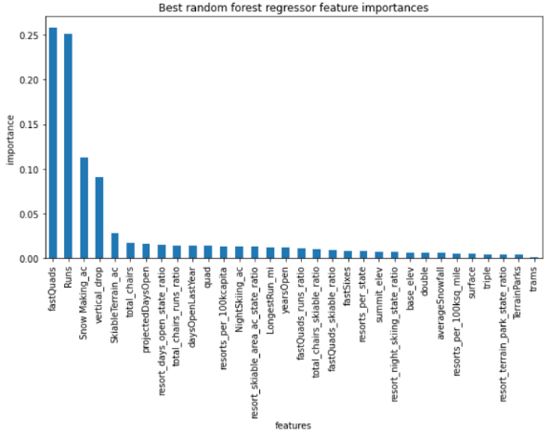 Two types of ticket pricing were included in our database: weekend ticketing and weekday ticketing. Weekend ticketing had the fewest missing values and correlated equally for the most part to weekday ticketing. As such, that is the data we focused on.

Resorts were localized by state and population and no substantial trends expressed themselves. During initial analysis, as seen to the right, runs, fast quads, snow making, and vertical drops were shown to be some of the primary resort features that affected mean and median ticket pricing country wide. A Linear Model (LM) and a Random Forest Model (RFM) were created to confirm that preliminary observation. By cross validating the two models, the RFM was shown to have the lowest mean absolute error. As such, it was selected to further assess the Big Mountain Resort’s problem.

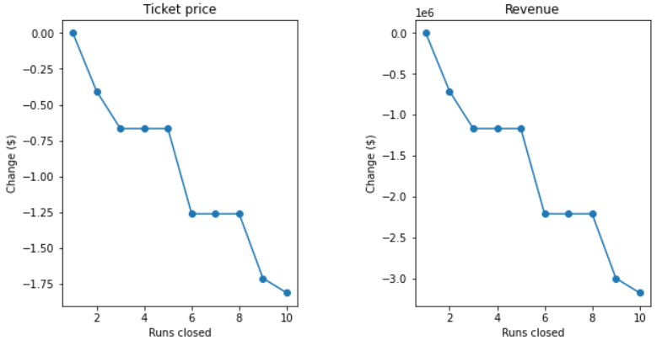 Given the four scenarios presented by management, it was shown that scenario 2 would result in a projected $3,474,638 in additional revenue per season. Scenario 3 resulted in no increase in ticketing price past scenario 2 according to the RFM. Scenario 4 resulted in no price increase at all. Scenario 1 will cut prices as seen to the right. Without the additional information of operational costs, seasonal net revenue is not known. At minimum, it is advised that at least one run is closed as this will have no impact on ticket price.

Scenario 1: Ticket Price Loss (left), Seasonal Revenue loss (right)